kiʔsuk kyukyit YNS Families,

Welcome back one and all for a most exciting, productive, and fulfilling 2022/2023 school year.

We ask that all families help their child prepare for the first day of in school learning on Monday, September 6th. Information regarding parent drop off instructions and bus route pick ups are provided below. The school calendar is also attached. Bus schedules will be sent out early next week. Printed copies of both will be sent home on the first day. We recognize there are a lot of details and we are happy to answer any questions.
The items below are ones that we believe are helpful to each child’s education. We understand that the costs of these educational tools can be expensive, we are here to support you and your family so please do not hesitate to contact us directly for support. Please note that the $45 registration fee covers the academic school supplies.

Required Items (please write your child’s name in marker on all items):
1. Backpack (all students require a backpack to be brought to and from school every day. This is helpful in carrying agenda, snacks, items for class, homework and memos from school but this is also the first step in student independence and responsibility)
**Students should carry their own backpack, not families!
- Lunch including healthy snacks/lunches (please pack healthy snacks/meals and limiting sugar items, please do not send pop or candy bars)
3. Indoor shoes/Sturdy outdoor shoes (clean, non-marking soles suitable for physical activity)
4. Reusable water bottle (to be used within the classroom and for lunch times)
5. Lots of sleep. We know this can be tricky but a well rested student has a mind that’s ready to learn!

We ask that ALL (shoes, backpacks, water bottle) are labelled with the student's name to ensure they are not lost.
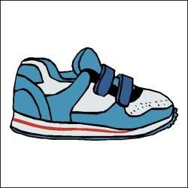
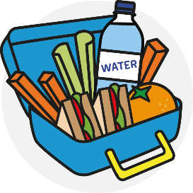

We thought you also might enjoy a few simple ideas that might help and your family gear up for a great school year:

- Make a plan for afterschool/evening activities.
- Scale back TV, video game, computer time.
- Establish bed times for school nights.
- Begin transition into earlier bed time and wake up to be on time for school and well rested for the first week.
- Get children in the habit of getting ready the night before school. Set out clothes, pack snacks, and put the backpack by the front door.

Reminder that school begins Tuesday, September 6th at 8:45 am for a full day. (Half day for Kindgarteners).

I trust these few hints will help, and I am excited for an awesome, inspiring, and memorable 2022-2023 school year!

ʔan wunikit

Kat Coleman (she/her)
kat@yaqannukiyschool.org

Renee Phypers (she/her)
admin@yaqannukiyschool.org
School Administrative Manager

Parent drop offs:

Parents will not be permitted to drop off their children before 8:35

School starts at 8:45.

AM: The drop off zone will be the eastern entrance to the school on the side of the Administration (Now Ktunaxa Kinbasket Child and Family Office) building. There will be clearly marked signs. Parents can park their vehicles in front the front of the administration building and send/escort children to the gate to enter the school playground. Student supervision will be available from 8:35 a.m. to 8:45 a.m.

PM: At the end of the day students will be let out in to the school yard for parent pick up or be lined up in front of the school to load busses. Parents can park in the parking lot in front of the administration building. Parents can come to the playground gate to pick up their children. Please use extreme caution when maneuvering in the parking lot.

New Students:

Ms. V and the EAs that work with her will be ready to greet the Kindergarten students the minute they arrive. Kindergarteners will be dismissed at 12:00 pm on the first few days. It is important that parents pick them up on time, but not too early. In the first two weeks of school, parents of Kindergartener’s must pick up children at the front door of the school. Ms. V and teachers assistants will be there to ensure your child is being picked up by an authorized pick-up person. This time can also be used for Ms. V to share briefly how the first few days of Kindergarten are going for your child. A video introduction of Ms. V will be sent out some time next week. Please play the video for your child so they feel less anxious about the first days of school.

Preparing your child:

Please be assured that we are very excited to have our students back in school.
Talking to your children about the first day of school and how to have a positive start to the school year will help them on those first few days of school.
- Bussing expectations: Staying seated on the ride. Learn where your seat is and memorize the number. Follow the bus driver's directions.
- Let an adult know if you are not feeling well.
- Do not share lunches
- Wash your hands when you enter a building, before and after you eat, after using the washroom and if they are visibly dirty.

