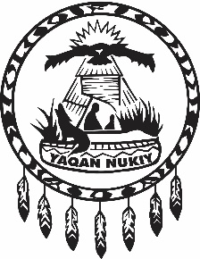
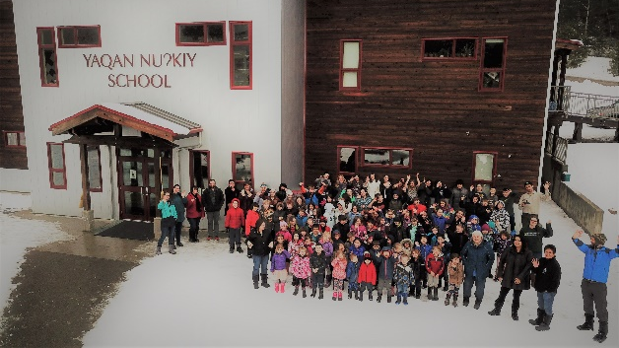

Purpose
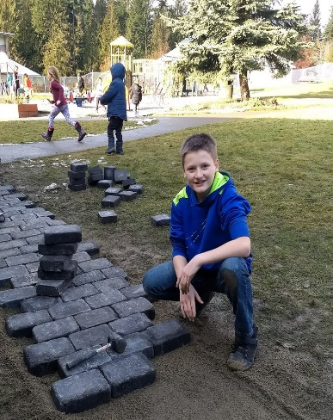
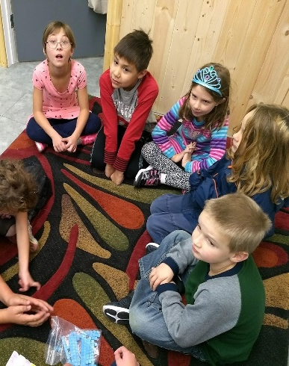
This code of conduct is written to help staff, students, volunteers, and families of YNS understand what it means to maintain a safe, caring and orderly environment and the consequences of interfering with that environment.
This code of conduct applies on and off premises, all YNS functions, and to electronic communications.
YNS promotes the values expressed in the BC Human Rights Code respecting the rights of all individuals in accordance with the law – prohibiting discrimination
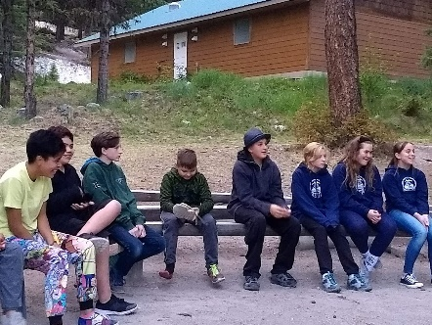
Be Safe Be Kind Be Respectful

Acceptable Behaviour
Everyone always needs to keep in mind that they are in a multi-age environment. Communication, even in free time, must be appropriate for all ages. Members of the YNS community are expected to be polite and respectful to all members of the community as well as be respectful of the school property and the property of others. Members of the YNS community acknowledge and respect that all programs function and operate differently within a common shared space. Members of the YNS community invest in the community and make the most positive contribution they can.
Unacceptable Behaviour
Unacceptable conduct refers to behaviour that is destructive to self, others, or property of the YNS community. Anything prohibited by law, Ministry of Education policy, or Lower Kootenay Band policy is prohibited within the YNS.

